# 3D PRINTER MATERIALS PREDICTION USING IBM WATSON

A MINI PROJECT REPORT

Submitted to

**JAWAHARLAL NEHRU TECHNOLOGICAL UNIVERSITY, HYDERABAD**

In partial fulfillment of the requirements for the award of the degree of

### BACHELOR OF TECHNOLOGY

**IN**

### COMPUTER SCIENCE AND ENGINEERING

Submitted by

### P.RAVICHANDRA 18UK1A0544

**A.AKSHAYA 18UK1A0563**

### J.KARTHIK 18UK1A0526

**B.SAHITHI 18UK1A0504**

Under the esteemed guidance of

### MR.VARUN REVURI

**(**Assistant Professor)



### DEPARTMENT OF COMPUTER SCIENCE AND ENGINEERING VAAGDEVI ENGINEERING COLLEGE

(Affiliated to JNTU Hyderabad & Approved by AICTE, New Delhi) Bollikunta , Warangal – 506005

### 2018 – 2022

**DEPARTMENT OF COMPUTER SCIENCE AND ENGINEERING**

# VAAGDEVI ENGINEERING COLLEGE

(Affiliated to JNTU Hyderabad & Approved by AICTE, New Delhi)Bollikunta , Warangal – 506005

**2018 – 2022**



**CERTIFICATE**

This is to certify that the Mini Project Report entitled **“3D PRINTER MATERIAL PREDICTION USING IBM WATSON”** is being submitted by **P.RAVICHANDRA(H.NO:18UK1A0544),A.AKSHAYA(H.NO:18UK1A0563),J.KARTHIK(H.NO:18UK1A0526),B.SAHITHI(H.NO:18UK1A0504)** in partial fulfillment of the requirements for the award of the degree of **Bachelor of Technology** in **Computer Science and Engineering** to **Jawaharlal Nehru Technological University Hyderabad** during the academic year **2020-21**, isa record of work carried out by them under the guidance and supervision.

#### Project Guide Head of the Department

**Mr.Dr.varun revuri Dr. R .Naveen Kumar**

(Asst Professor) (Professor)

**External**

**ACKNOWLEDGEMENT**

We wish to take this opportunity to express our sincere gratitude and deep sense of respect to our beloved **Dr.P.PRASAD RAO,** Principal, Vaagdevi Engineering College for making us available all the required assistance and for his support and inspiration to carry out this mini project in the institute.

We extend our heartfelt thanks to **Dr.R.NAVEEN KUMAR**, Head of the Department of CSE, Vaagdevi Engineering College for providing us necessary infrastructure and there by giving us freedom to carry out the mini project.

We express heartfelt thanks to **Mr.Ch.Jayaprakash**, Program Manager, SmartBridge Educational Services Private Limited,for their constant supervision as well as for providing necessary information regarding the major project and for their support in completing the major project ,mini project and internship.

We express heartfelt thanks to the guide, **Mr varun revuri** Assistant professor, Department of CSE for her constant support and giving necessary guidance for completion of this mini project.

Finally, we express our sincere thanks and gratitude to my family members, friends for their encouragement and outpouring their knowledge and experience throughout the thesis.

#### P.RAVICHANDRA 18UK1A0544

**A.AKSHAYA 18UK1A0563 , J.KARTHIK 18UK1A0526**

**B.SAHITHI 18UK1A0504**

**INDEX**

**TITLE PAGE NO**

**CHAPTER 1: INTRODUCTION** 3

* 1. OVERVIEW 3
  2. PURPOSE 3

**CHAPTER 2: LITERATURE SURVEY 3-4**

* 1. EXISTING PROBLEM 3
  2. PROPOSED SOLUTION 4

**CHAPTER 3: THEORTICAL ANALYSIS 4-5**

3.1 BLOCK DIAGRAM 4

3.2 HARDWARE/SOFTWARE DESIGNING 5

**CHAPTER 4: EXPERIMENTAL INVESTIGATIONS 6-7**

**CHAPTER 5: FLOW CHART 7-8**

**CHAPTER 6: RESULTS 8-10**

**CHAPTER 7: ADVANTAGES AND DISADVANTAGES 10-11**

**CHAPTER 8: APLLICATIONS 11**

**CHAPTER 9: CONCLUSION 11**

**CHAPTER 10: FUTURE SCOPE 12**

**CHAPTER 11: BIBILOGRAPHY 12**

**CHAPTER 12:APPENDIX 13-30**

**CHAPTER 1**

**INTRODUCTION**

* 1. **Overview:**

The goal of this analysis is to create a model that suggests the best material to use for the required 3D shape among ABS (Acrylonitrile Butadiene Styrene) and PLA (Poly-actic Acid). Let’s understand the data we’re working with and give a brief overview of what each feature represents or should represent.

1. Layer Height (mm) – Height of the layer

2. Wall Thickness (mm) – Thickness of wall of desired 3d shape

3. Infill Density (mm) – Density of infill

4. Infill pattern – Grid or Honeycomb

5. Nozzle Temperature (°C) – Temperature of nozzle

6. Bed Temperature (°C) - Temperature of printing bed

7. Print speed (mm/s) – Speed of printing

8. Fan speed (mm/s) – speed of fan

9. Roughness

10. Tension strength

11. Elongation

**1.2 Purpose:**

By 3D Printer Materials Prediction Using IBM Watson we will:

* Know fundamental concepts and can work on IBM Watson Studio.
* Gain a broad understanding of Binary Classification.

**CHAPTER 2**

**LITERATURE SURVEY**

* 1. **Existing Problem:**

Determining the best material for 3D printer is a difficult task for a human as he has to consider different number of parameters and come up with a conclusion. Once after deciding the material we can’t roll back the task of printing and sometimes it turns out to a huge loss.

It is quite difficult for a human to work with such a huge and typical data. So here we are coming up with a solution.

* 1. **Proposed Solution:**

Artificial Intelligence being the trending technology can end up with the best solution for every typical problem. So here we are going to use the rich set of Machine Learning algorithms to predict the material.

By using the supervised learning algorithms of Machine learning such as decision tree we decide the material to be used.

**CHAPTER 3**

**THEORTICAL ANALYSIS**

**3.1 Block Diagram:**

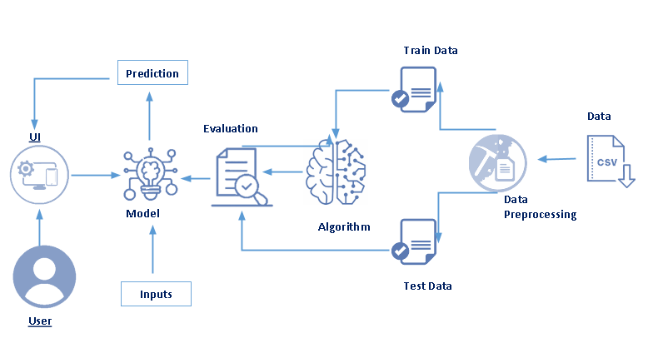

**3.2 Hardware/software designing:**

**Software specifications:**

|  |  |
| --- | --- |
| **REQUIREMENT** | **SPECIFICATION** |
| Anaconda Navigator | You must have anaconda installed in your device prior to begin. |
| Spyder, Jupyter Notebook, Flask  Frame work | 1. One should have Spyder and Jupyter notebook. 2. One should install flask framework through anaconda prompt for running their web application 3. We need to build the model using Jupyter notebook with all the imported packages. |
| Web browser | For all Web browsers, the following must be enabled:   * cookies * JavaScript |

**Hardware Specifications:**

|  |  |
| --- | --- |
| **REQUIREMENT** | **SPECIFICATIONS** |
| Operating system | Microsoft Windows  UNIX  Linux® |
| Processing | Minimum: 4 CPU cores for one user. For each deployment, a sizing exercise is highly recommended. |
| RAM | Minimum 8 GB. |
| Operating system specifications | File descriptor limit set to 8192 on UNIX and Linux |
| Disk space | A minimum of 7 GB of free space is required to install the software. |

**CHAPTER 4**

**EXPERIMENTAL INVESTIGATIONS**

Analysis or the investigation made while working on the solution:

While working on the solution we investigated on what is 3D Printing, IBM cloud, IBM Watson studio, Machine Learning service, Cloud Object Storage. The key role on investigation is collection of dataset.

**IBM Cloud Account**:

IBM Acquired soft layer, a public cloud platform, to serve as the foundation for its IaaS offering. In October 2016, IBM rolled the soft layer brand under its Blue mix brand of PaaS offerings, giving users to access both IaaS and PaaS resources from a single console. IBM cloud provides a full-stack, public cloud platform with various products in the catalog, including options for compute, storage, networking, end to end developer solutions for app development, testing and deployment, security databases, and cloud native services.

Creating the IBM cloud account by going to the IBM cloud login page and click create on IBM cloud account. Enter our IBM id and an ID is created based on the email that we enter. Completing the remaining fields with our information and click create account by this the account is created.

**Dataset collection**:

The data collection on 3d printer by:

* Articulate the problem early.
* Establish data collection.
* Check our data quickly.
* Format data to make it consistent.
* Reduce data.
* Complete data cleaning.
* Decompose data.
* Take the required fields of data.

**Model Building:**

* Training and testing the model
* Evaluation of Model
* Save the model
* Predicting the output using the model

**CHAPTER 5**

**FLOW CHART**

**CHAPTER 6**

**RESULTS**

**Final output of the project:**



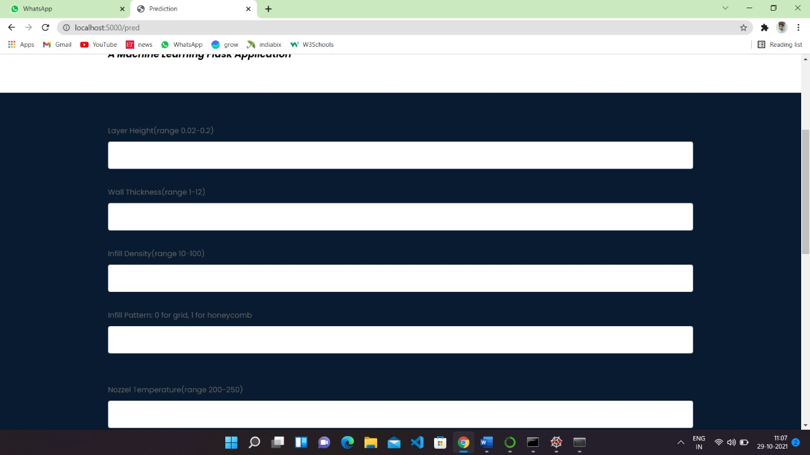

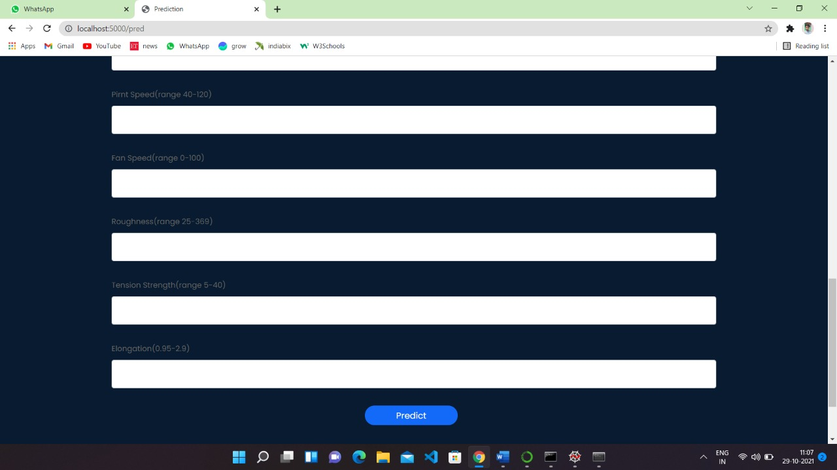

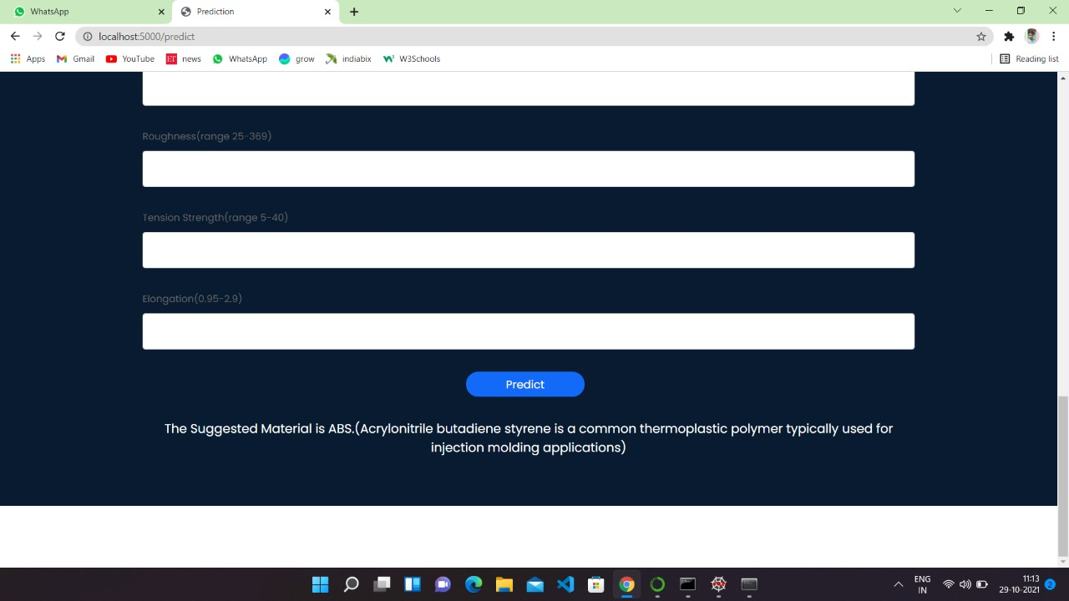

**CHAPTER 7**

**ADVANTAGES AND DISADVANTAGES**

**Advantages:**

* Lower costs - reduces maintenance due to complete report coverage and a zero-footprint environment.
* Faster results - shortens reporting time due to seamless integration and adaptive authoring.
* High performance data access across all source.

**Disadvantages:**

* The permission level for a user cannot be modified
* Data grouping
* Custom visualizations
* Insights in visualization

Lower c Lower costs—reduces maintenance due to complete report co

-footprint environment.

Faster results—shortens reporting time due to seamless integration and adaptive authoring.

Improved decision making—reports and dashboards present data in easily-understood formats.

High performance data ac **CHAPTER 8**

**APLLICATIONS**

**The areas where this solution can be applied:**

* 3D Printing Industry
* Where there is an ambiguity between two materials.

**CHAPTER 9**

**CONCLUSION**

**From this entire findings we know fundamental concepts and can work on IBM Watson and machine learning.**

* Gain a board understanding of Binary classification algorithms.
* Learn to build stunning models on IBM cloud.
* To create data visualizations to understand.

**CHAPTER 10**

**FUTURE SCOPE**

**Enhancements that can be made in the future:**

* This model can be further developed to suggest material among all the possible materials based on the input parameters.
* We can scope the better job in future with easy experience.

**CHAPTER 11**

**BIBILOGRAPHY**

References of previous works or websites visited/books referred for analysis about the project, previous solution findings

https://www.analyticsvidhya.com/blog/2017/09/common-machine-learning-algorithms

**APPENDIX**

**home.html**

<!DOCTYPE html>

<html lang="en">

<head>

<!-- basic -->

<meta charset="utf-8">

<meta http-equiv="X-UA-Compatible" content="IE=edge">

<!-- mobile metas -->

<meta name="viewport" content="width=device-width, initial-scale=1">

<meta name="viewport" content="initial-scale=1, maximum-scale=1">

<!-- site metas -->

<title>3D material prediction</title>

<meta name="keywords" content="">

<meta name="description" content="">

<meta name="author" content="">

<!-- bootstrap css -->

<link rel="stylesheet" href="/static/css/bootstrap.min.css">

<!-- style css -->

<link rel="stylesheet" href="/static/css/style.css">

<!-- Responsive-->

<link rel="stylesheet" href="/static/css/responsive.css">

<!-- fevicon -->

<link rel="icon" href="/static/images/fevicon.png" type="image/gif" />

<!-- Scrollbar Custom CSS -->

<link rel="stylesheet" href="/static/css/jquery.mCustomScrollbar.min.css">

<!-- Tweaks for older IEs-->

<link rel="stylesheet" href="https://netdna.bootstrapcdn.com/font-awesome/4.0.3/css/font-awesome.css">

<!-- owl stylesheets -->

<link rel="stylesheet" href="/static/css/owl.carousel.min.css">

<link rel="stylesheet" href="/static/css/owl.theme.default.min.css">

<link rel="stylesheet" href="https://cdnjs.cloudflare.com/ajax/libs/fancybox/2.1.5/jquery.fancybox.min.css" media="screen">

<!--[if lt IE 9]>

<script src="https://oss.maxcdn.com/html5shiv/3.7.3/html5shiv.min.js"></script>

<script src="https://oss.maxcdn.com/respond/1.4.2/respond.min.js"></script><![endif]-->

</head>

<!-- body -->

<body class="main-layout about_pape">

<!-- loader -->

<div class="loader_bg">

<div class="loader"><img src="/static/images/loading1.gif" alt="#" /></div>

</div>

<!-- end loader -->

<!-- header -->

<header class="section">

<!-- header inner -->

<div class="header_main">

<div class="header_main">

<div class="container">

<div class="row">

<div class="col-xl-3 col-lg-3 col-md-3 col-sm-3 col logo_section">

<div class="full">

<div class="center-desk">

<div class="logo"> <a href="home.html"><img src="/static/images/logo2.jpg" alt="#" ></a> </div>

</div>

</div>

</div>

<div class="col-xl-9 col-lg-9 col-md-9 col-sm-9">

<div class="menu-area">

<div class="limit-box">

<nav class="main-menu">

<ul class="menu-area-main">

<li>

<a href="/home">Home<span class="sr-only">(current)</span></a>

</li>

<li>

<a href="/pred">Predict</a>

</li>

</ul>

</nav>

</div>

</div>

</div>

</div>

</div>

</div>

</div>

<!-- end header inner -->

</header>

<!-- end header -->

<!--about -->

<div class="section about ">

<div class="container">

<div class="row">

<div class="col-12">

<div class="titlepage">

<h2><strong class="black"> 3D Printer Material</strong> Prediction</h2>

<span>The 3D printing materials industry is increasing due to the rise in the demand from healthcare,

automotive, and other industries, globally.The 3D printing materials market comprises several

stakeholders, such as raw material suppliers, processors, end-product manufacturers, and regulatory

organizations in the supply chain. The demand side of this market is characterized by the development

of various industries such as aerospace & defense, healthcare, consumer goods, and automotive.

Advancements in technology and diverse applications characterize the supply side. Various primary

sources from both the supply and demand sides of the market were interviewed to obtain qualitative

and quantitative information.

</span>

</div>

</div>

</div>

</div>

</div>

<section >

<div id="main_slider" class="section carousel slide banner-main" data-ride="carousel">

<ol class="carousel-indicators">

<li data-target="#main_slider" data-slide-to="0" class="active"></li>

<li data-target="#main_slider" data-slide-to="1"></li>

<li data-target="#main_slider" data-slide-to="2"></li>

</ol>

<div class="carousel-inner">

<div class="carousel-item active">

<div class="container">

<div class="row marginii">

<div class="col-xl-6 col-lg-6 col-md-6 col-sm-12">

<div class="carousel-sporrt_text ">

<h1 class="sporrt_text">About the Project</h1>

<p class="lorem_text">Predicting material would be more suitable for making the 3D model.

In this project the input parameters are like Layer Height (mm),Wall Thickness (mm),

Infill Density (%),Infill Pattern (honey comb, grid),Nozzle Temperature (Cº),Bed Temperature (Cº),

Print Speed(mm/s),Fan Speed (%), Roughness (µm),Tension (ultimate), Strength (MPa),Elongation (%).

</p>

<div class="btn_main">

<a class="btn btn-lg btn-primary" href="#" role="button">Read More</a>

</div>

</div>

</div>

<div class="col-xl-6 col-lg-6 col-md-6 col-sm-12">

<div class="img-box">

<figure><img src="/static/images/model.png" style="max-width: 100%; border: 15px solid #fff;"/></figure>

</div>

</div>

</div>

</div>

</div>

<div class="carousel-item">

<div class="container">

<div class="row marginii">

<div class="col-xl-6 col-lg-6 col-md-6 col-sm-12">

<div class="carousel-sporrt_text ">

<h1 class="sporrt_text">About the Project</h1>

<p class="lorem_text">Based on these parameters a supervised machine learning model is built

to predict the best material to be used for building 3D models. A web application is build so that

the user can type in the mentioned parameters and the material which suits the best is show cased on UI</p>

<div class="btn_main">

<a class="btn btn-lg btn-primary" href="#" role="button">Read More</a>

</div>

</div>

</div>

<div class="col-xl-6 col-lg-6 col-md-6 col-sm-12">

<div class="img-box ">

<figure><img src="/static/images/model.png" style="max-width: 100%; border: 15px solid #fff;"/></figure>

</div>

</div>

</div>

</div>

</div>

</div>

</div>

</section>

</div>

<!--end about -->

<!-- footer start-->

<div class="copyright_text">

<div id="plant" class="footer layout_padding">

<div class="container">

</div>

</div>

</div>

<!-- Javascript files-->

<script src="/static/js/jquery.min.js"></script>

<script src="/static/js/popper.min.js"></script>

<script src="/static/js/bootstrap.bundle.min.js"></script>

<script src="/static/js/jquery-3.0.0.min.js"></script>

<script src="/static/js/plugin.js"></script>

<!-- sidebar -->

<script src="/static/js/jquery.mCustomScrollbar.concat.min.js"></script>

<script src="/static/js/custom.js"></script>

<!-- javascript -->

<script src="/static/js/owl.carousel.js"></script>

<script src="https:cdnjs.cloudflare.com/ajax/libs/fancybox/2.1.5/jquery.fancybox.min.js"></script>

<script>

$(document).ready(function(){

$(".fancybox").fancybox({

openEffect: "none",

closeEffect: "none"

});

$(".zoom").hover(function(){

$(this).addClass('transition');

}, function(){

$(this).removeClass('transition');

});

});

</script>

</body>

</html>

**Results.html**

<!DOCTYPE html>

<html lang="en">

<head>

<!-- basic -->

<meta charset="utf-8">

<meta http-equiv="X-UA-Compatible" content="IE=edge">

<!-- mobile metas -->

<meta name="viewport" content="width=device-width, initial-scale=1">

<meta name="viewport" content="initial-scale=1, maximum-scale=1">

<!-- site metas -->

<title>Prediction</title>

<meta name="keywords" content="">

<meta name="description" content="">

<meta name="author" content="">

<!-- bootstrap css -->

<link rel="stylesheet" href="/static/css/bootstrap.min.css">

<!-- style css -->

<link rel="stylesheet" href="/static/css/style.css">

<!-- Responsive-->

<link rel="stylesheet" href="/static/css/responsive.css">

<!-- fevicon -->

<link rel="icon" href="/static/images/fevicon.png" type="image/gif" />

<!-- Scrollbar Custom CSS -->

<link rel="stylesheet" href="/static/css/jquery.mCustomScrollbar.min.css">

<!-- Tweaks for older IEs-->

<link rel="stylesheet" href="https://netdna.bootstrapcdn.com/font-awesome/4.0.3/css/font-awesome.css">

<!-- owl stylesheets -->

<link rel="stylesheet" href="/static/css/owl.carousel.min.css">

<link rel="stylesheet" href="/static/css/owl.theme.default.min.css">

<link rel="stylesheet" href="https://cdnjs.cloudflare.com/ajax/libs/fancybox/2.1.5/jquery.fancybox.min.css" media="screen">

<!--[if lt IE 9]>

<script src="https://oss.maxcdn.com/html5shiv/3.7.3/html5shiv.min.js"></script>

<script src="https://oss.maxcdn.com/respond/1.4.2/respond.min.js"></script><![endif]-->

</head>

<!-- body -->

<body class="main-layout product_pagr">

<!-- loader -->

<div class="loader_bg">

<div class="loader"><img src="/static/images/loading1.gif" alt="#" /></div>

</div>

<!-- end loader -->

<!-- header -->

<header class="section">

<!-- header inner -->

<div class="header_main">

<div class="header_main">

<div class="container">

<div class="row">

<div class="col-xl-3 col-lg-3 col-md-3 col-sm-3 col logo_section">

<div class="full">

<div class="center-desk">

<div class="logo"> <a href="home.html"><img src="/static/images/logo2.jpg" alt="#" ></a> </div>

</div>

</div>

</div>

<div class="col-xl-9 col-lg-9 col-md-9 col-sm-9">

<div class="menu-area">

<div class="limit-box">

<nav class="main-menu">

<ul class="menu-area-main">

<li>

<a href="/home">Home</a>

</li>

<li>

<a href="/pred">Predict<span class="sr-only">(current)</span></a>

</li>

</ul>

</nav>

</div>

</div>

</div>

</div>

</div>

</div>

</div>

<!-- end header inner -->

</header>

<!-- end header -->

</header>

<!-- end header -->

<!-- plant -->

<div id="plant" class="section product">

<div class="container">

<div class="row">

<div class="col-md-12 ">

<div class="titlepage">

<h2><strong class="black"> 3D Printer Material</strong> Prediction</h2></strong>

<h3><strong class="black"><i> A Machine Learning Flask Application</i></strong>

</div>

</div>

</div>

</div>

</div>

<div class="clothes_main section ">

<div class="container">

<form action="{{ url_for('predict')}}" method="post">

<div class="form-group">

<label for="layer_height">Layer Height(range 0.02-0.2)</label>

<input type="text" class="form-control" name="layer_height" id="layer_height">

</div>

<div class="form-group">

<label for="wall_thickness">Wall Thickness(range 1-12)</label>

<input type="text" class="form-control" name="wall_thickness" id="wall_thickness">

</div>

<div class="form-group">

<label for="infill_density">Infill Density(range 10-100)</label>

<input type="text" class="form-control" name="infill_density" id="infill_density">

</div>

<div class="form-group">

<label for="infill_pattern">Infill Pattern: 0 for grid, 1 for honeycomb</label>

<input type="text" class="form-control" name="infill_pattern" id="infill_pattern">

</div><br>

<div class="form-group">

<label for="nozzle_temperature">Nozzel Temperature(range 200-250)</label>

<input type="text" class="form-control" name="nozzle_temperature" id="nozzle_temperature">

</div>

<div class="form-group">

<label for="bed_temperature">Bed Temperature(range 60-100)</label>

<input type="text" class="form-control" name="bed_temperature" id="bed_temperature">

</div>

<div class="form-group">

<label for="print_speed">Pirnt Speed(range 40-120)</label>

<input type="text" class="form-control" name="print_speed" id="print_speed">

</div>

<div class="form-group">

<label for="fan_speed">Fan Speed(range 0-100)</label>

<input type="text" class="form-control" name="fan_speed" id="fan_speed">

</div>

<div class="form-group">

<label for="roughness">Roughness(range 25-369)</label>

<input type="text" class="form-control" name="roughness" id="roughness">

</div>

<div class="form-group">

<label for="tension_strenght">Tension Strength(range 5-40)</label>

<input type="text" class="form-control" name="tension_strenght" id="tension_strenght">

</div>

<div class="form-group">

<label for="elongation">Elongation(0.95-2.9)</label>

<input type="text" class="form-control" name="elongation" id="elongation">

</div>

<div class="form-group" id="submit">

<center><button type="submit" class="btn btn-primary btn-block btn-large" id="submit" value="Predict"> Predict</button></center>

</div>

<style>

h3{

color:white;

font-size:22;

}

</style>

<div id="output">

<center><h3>{{ prediction_text }}</h3></center>

</div>

</form>

</div>

</div>

</div>

<!-- end plant -->

<!-- footer start-->

<div id="plant" class="footer layout_padding">

<div class="container">

</div>

</div>

<!-- Javascript files-->

<script src="/static/js/jquery.min.js"></script>

<script src="/static/js/popper.min.js"></script>

<script src="/static/js/bootstrap.bundle.min.js"></script>

<script src="/static/js/jquery-3.0.0.min.js"></script>

<script src="/static/js/plugin.js"></script>

<!-- sidebar -->

<script src="/static/js/jquery.mCustomScrollbar.concat.min.js"></script>

<script src="/static/js/custom.js"></script>

<!-- javascript -->

<script src="/static/js/owl.carousel.js"></script>

<script src="https:cdnjs.cloudflare.com/ajax/libs/fancybox/2.1.5/jquery.fancybox.min.js"></script>

<script>+

$(document).ready(function(){

$(".fancybox").fancybox({

openEffect: "none",

closeEffect: "none"

});

$(".zoom").hover(function(){

$(this).addClass('transition');

}, function(){

$(this).removeClass('transition');

});

});

</script>

</body>

</html>

# REFERENCES

* [Raicharoen et al, 2003] T. Raicharoen, C. Lursinsap, P. Sanguanbhoki, Application of critical support vector machine to time series prediction, Circuits and Systems, 2003. In: ISCAS ’03.Proceedings of the 2003 International Symposium on Vol. 5, 25-28 May, 2003. pp. V-741-V-744
* [Zhang, 2003] G.P. Zhang, Time series forecasting using a hybrid ARIMA and neural network model, Neurocomputing, Vol. 50, 2003, pp. 159–175.
* [Zhang, 2007] G.P. Zhang, A neural network ensemble method with jittered training data for time series forecasting. Information Sciences, Vol. 177 Issue 23, 2007. pp. 5329–5346.
* [Cochrane, 1997] John H. Cochrane, Time Series for Macroeconomics and Finance, Graduate School of Business, University of Chicago, Spring 1997.
* [Hipel and McLeod, 1994] K.W. Hipel, A.I. McLeod, Time Series Modelling of Water Resources and Environmental Systems. Amsterdam, Vol. 45, 1st Edition, Elsevier 1994.
* [Lee] J. Lee, Univariate time series modeling and forecasting (Box-Jenkins Method), Econ 413, lecture 4.
* [Box et al, 1970] G.E.P. Box, G. Jenkins, Time Series Analysis, Forecasting and Control. Holden-Day, San Francisco, CA, 1970.
* [Hochreiter and Schmidhuber, 1997 a] Hochreiter S, Schmidhuber J. Long Short-Term Memory. Neural Computation, Vol. 9, Issue 8, 1997, pp.1735–80.
* [Hochreiter and Schmidhuber, 1997 b] Sepp Hochreiter, Jürgen Schmidhuber, Neural Computation, Vol. 9, Issue 8, 1997, pp. 1735-1780.
* [El-Din et al, 2017] M. M. Mohie El-Din, M. S. Farag and A. A. Abouzeid, Airline Passenger Forecasting in EGYPT (Domestic and International), International Journal of Computer Application (0975-8887), Vol. 165, Issue.6, May 2017.
* [Bao et al, 2012] Yukun Bao, Tao Xiong, and Zhongyi Hu, Forecasting Air Passenger Traffic by Support Vector Machines with Ensemble Empirical
* Abed, S. Y., Ba-Fail, A. O., & Jasimuddin, S. M. (2001). An econometric analysis of international air travel demand in Saudi Arabia. Journal of air transport management, 7(3), 143-148.
* Aderamo, A. J. (2010). Demand for air transport in Nigeria. Journal of Economics, 1(1), 23-31. Barboza, F., & Kimura, H. E. Altman. (2017). Machine learning models and bankruptcy prediction. Expert Systems with Applications, 83, 405-17.
* Bermúdez, J. D., Segura, J. V., & Vercher, E. (2007). Holt–Winters forecasting: an alternative formulation applied to UK air passenger data. Journal of Applied Statistics, 34(9), 1075-1090. Duval, D. T., & Schiff, A. (2011). Effect of air services availability on international visitors to New Zealand. Journal of Air Transport Management, 17(3), 175-

180. El-Din, M. M., Farag, M. S., & Abouzeid, A. A. (2017). Airline passenger forecasting in Egypt (domestic and international). International Journal of Computer Applications, 165(6), 1-5.

* Grosche, T., Rothlauf, F., & Heinzl, A. (2007). Gravity models for airline passenger volume estimation. Journal of Air Transport Management, 13(4), 175-183.
* Hochreiter, S., & Schmidhuber, J. (1997). Long shortterm memory. Neural computation, 9(8), 1735-1780.
* Kim, S. (2016). Forecasting short-term air passenger demand using big data from search engine queries. Automation in Construction, 70, 98-108. Makridakis, S., & Hibon, M.

(1997). ARMA models and the Box–Jenkins methodology. Journal of Forecasting, 16(3), 147-163. Nam, K., & Schaefer, T. (1995). Forecasting international airline passenger traffic using neural networks. The Logistics and Transportation Review, 31(3), 239-252.

* Profillidis, V. Α. (2012). An ex-post assessment of a passenger demand forecast of an airport. Journal of Air Transport Management, 25, 47-49.
* Samagaio, A., & Wolters, M. (2010). Comparative analysis of government forecasts for the Lisbon Airport. Journal of Air Transport Management, 16(4), 213-217.
* Scarpel, R. A. (2013). Forecasting air passengers at São Paulo International Airport using a mixture of local experts model. Journal of Air Transport Management, 26, 35-39.
* Schmidhuber, J. (2015). Deep learning in neural networks: An overview. Neural networks, 61, 85-117. Schultz, M., & Reitmann, S. (2019). Machine learning approach to predict aircraft boarding. Transportation Research Part C: Emerging Technologies, 98, 391-408.
* Suryani, E., Chou, S. Y., & Chen, C. H. (2010). Air passenger demand forecasting and passenger terminal capacity expansion: A system dynamics framework. Expert Systems with Applications, 37(3), 2324-2339.
* Tsui, W. H. K., Balli, H. O., Gilbey, A., & Gow, H. (2014). Forecasting of Hong Kong airport's passenger throughput. Tourism Management, 42, 62-76. Xie, G., Wang, S., & Lai, K. K. (2014). Short-term forecasting of air passenger by using hybrid seasonal decomposition and least squares support vector regression approaches. Journal of Air Transport Management, 37, 20-26.